

Cooking, Eating
Monday
Saturday
How a Mother and Daughter
Spend their Time
Boomers V.S. Millennials

These two generations just can’t seem to understand
each other but they may have more in common than they think. Afterall, they’re related.
A look into a week of activities between one North Carolina based mother and her bustling New York City daughter might finally help boomers and millennials bury the hatchet and bust a few myths between one another.
Friday
Sunday
Daughter
Mother
Daily Screen time
Entertainment




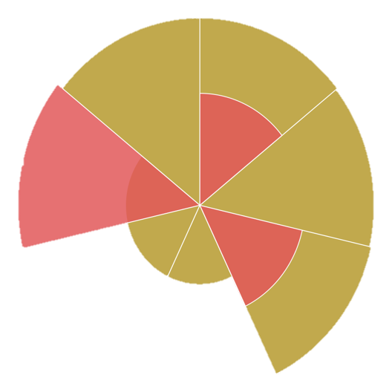
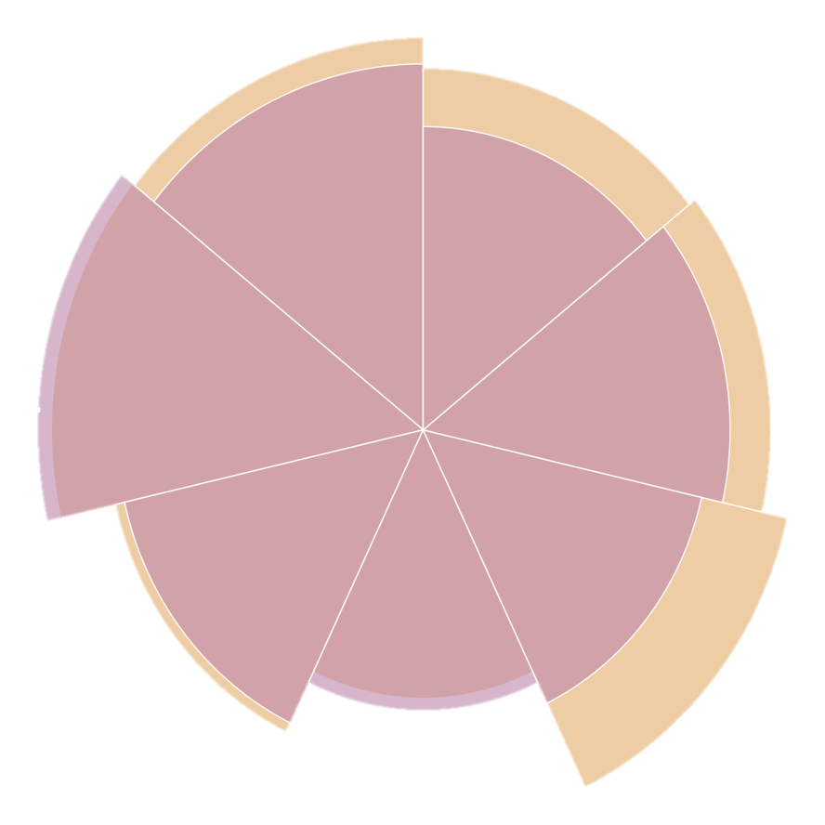


Thursday
Tuesday
Wednesday
Screen Activity
Eating out/Delivery

Cooking/Meal Prep
Daily Steps
Commuting
Exercise

Social Networking
Physical Activity
Reading & Referencing

